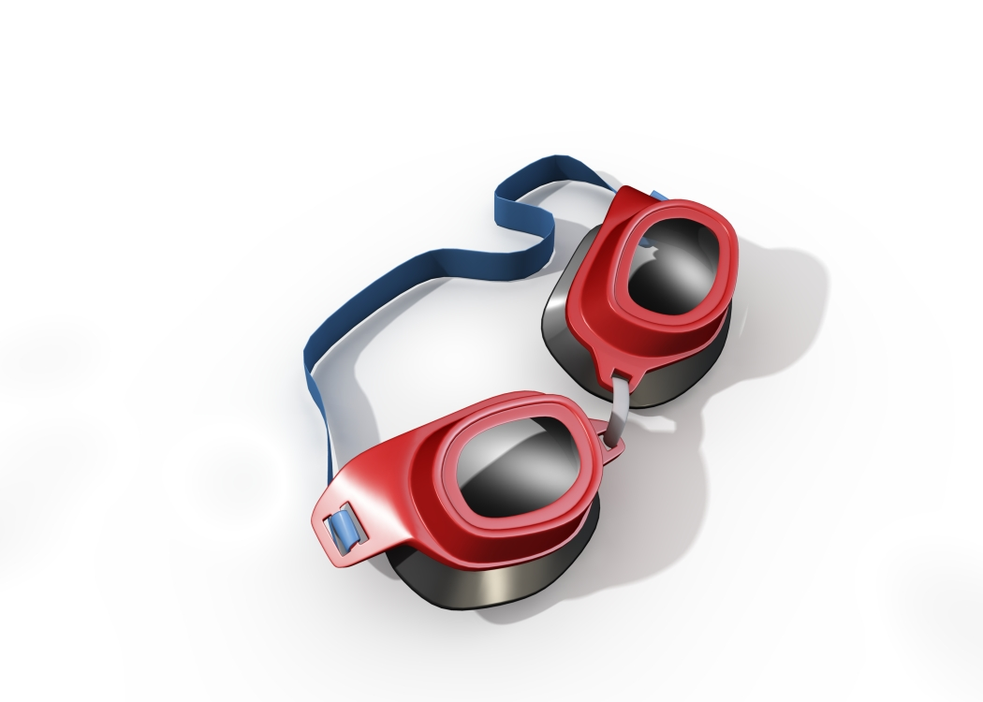
 Community Education
2013
INTRO TO COMPETITIVE
SWIMMING

This camp is designed for swimmers with little or no competitive experience who would like to join a swim team. Students will be taught the 4 competitive strokes as well as starts and turns. All individuals should be comfortable in the water and capable of swimming 25 yards (1 length). Coaches – Dave Smith and Tony Grice.


Location: | Ford High School
Grades: | 3-6 (Summer 2013)
Dates: | June 17 -July 29 (M/W/F)  No camp week of July 1  and Friday, July 12 and 26
Times: | 9:00-10:00 am
Cost: | $100
Camp #: | 6146C
To register by phone with a Visa, Master Card or Discover, please call UCS Community Education
(586) 797- 6900 OR mail the completed application below with your check (payable to UCS) to Utica Community Schools, Community Education, 38901 Dodge Park Rd., Sterling Hts., MI 48312. To register online, visit www.ucscommunityeducation.com. No refunds.

2013 Intro to Competitive Swimming - #6146C

Name

Address_____________________________City___________________________Zip

Home Phone _________________________ Work/Cell Phone

Last Grade Completed _____School

E-mail address_______________________________________________CASH___CHECK#

Visa/MC/Discover #__________________________________________________ EXP.DATE

CARDHOLDER’S NAME

CARDHOLDER’S ADDRESS

